

RANGKUMAN QUIZ MODUL 3 & 4

Tugas Keamanan Jaringan Minggu 1



February 26, 2023

Fajar yunus afiffudin

NRP 3122640049

**QUIZ 3**

1. Reviewing access and activities from log files is an example of which of the following security controls?

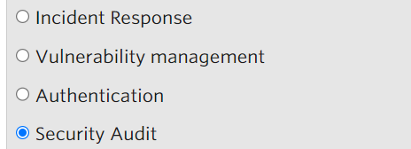

The activity of reviewing logs is part of a security audit, because this activity checks whether a problem has occurred.

1. Which of the following activities is related to vulnerability management

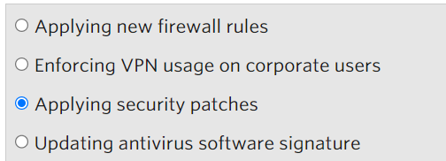

For the vulnerability is to update the latest patch to make it more secure

1. Which of the following security controls can be used to limit access to certain servers hosted in a facility?

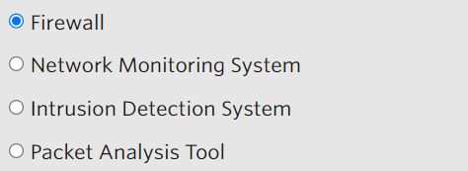

To limit access, you can use the host firewall, the firewall can limit access from source and destination ports, and determine whether it is allowed or denied

1. Cyber Security Frameworks can help organizations to

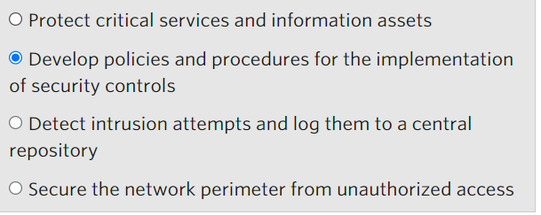

A security framework or standard is a set of documented processes used to define policies and procedures around the implementation and ongoing management of security controls is the corporate environment.

1. Access to an internal server can be limited by using which of the following security control?

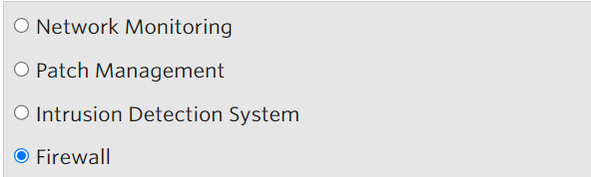

To limit access to the server can use a firewall

1. Securing the data centre with locks and closed-circuit television (CCTV) is an example of which security control category?

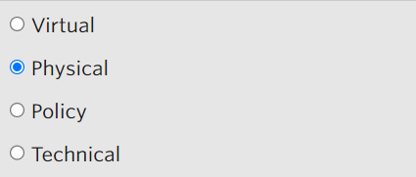

Cctv to monitor anyone accessing the physical server location, because if it is not detected through the logs it can be seen via cctv

1. Which of the following controls can be used to protect data that is traversing the network?  
   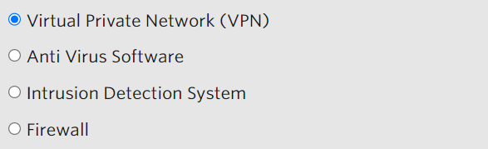

VPN can disguise servers, so traversing is safer

**Modul 4**

1. Which role normally deals with data recovery and examination after a security breach?

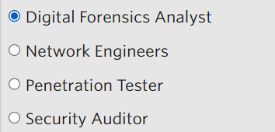

1. Which of the following is ultimately responsible for formulating the security strategy and making sure that resources are allocated for the organization-wide security program?

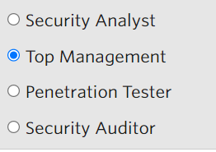

Because top management determines the allocation of costs for security, and approves policies

1. One of the responsibilities of a security auditor is to

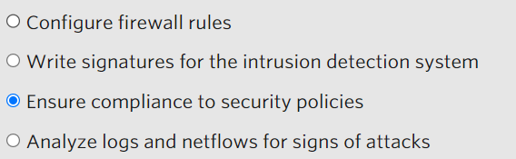

The task of the security auditor is to ensure implementation is in accordance with the security policy made by the security analyst

1. Which role is responsible for ensuring internally developed web applications are not vulnerable to attacks such as SQL injection or Cross-Site Scripting?

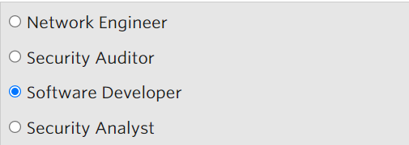

Those responsible for software are software developers